DAO IPCI
DECENTRALIZED AUTONOMOUS ORGANIZATION «INTEGRAL PLATFORM FOR CLIMATE INITIATIVES»
Public programmable blockchain ecosystem for carbon markets, societal cost mitigation instruments, environmental assets, rights and liabilities

DAO IPCI is a Decentralized Autonomous Organization operating, sustaining and developing the Integral Platform for Climate Initiatives. DAO IPCI is a public and programmable blockchain-based independent ecosystem designed for societal cost markets and mitigation instruments, including carbon markets and instruments, carbon compliance units, carbon emission allowances, offset credits, renewable energy credits, other environmental credits, and financial instruments, environmental assets, rights and liabilities in general.
DAO IPCI – a truly decentralized public blockchain ecosystem – is a private nonprofit project independent of specific government, corporate, business or NGO interests.

Contents
Executive Summary 4
Definitions 6
Introduction 8
Concept design 15
Participants, Mitigation Programs and Environmental Units, Functional Modules and Operations 23
DAO IPCI offsetting carbon footprint scheme 26
‘Blockchainization’ of the Paris agreement 27
Scheme for Carbon Offsetting and Reduction Scheme for International Aviation (CORSIA) 31
Mitigation Token 32
Prospects and plans of development 36

Executive Summary

It is quite common for the people stumbling upon complicated issues to set hopes on a central authority to resolve them rather than proposing an algorithm for the individuals to preserve their fundamental right to economic choice and settle problems on decentralized peer-to-peer basis.
Ronald Coase, 1910 – 2013, a British economist, Nobel Prize Winner in Economic Sciences in 1991, proposed a general market-approach to the problem of social cost and a solution based on clearly defined property rights. The approach introduced the concept of delimitation of rights to perform activities harmful to third party and provided the basis for the market-based distribution of limited resources as a production factor and for a peer-to-peer settlement of reciprocal damage of part A (the manufacturer) and part B (the third party).
The advance of decentralized arbitration, distributed ledger, Turing complete, and momentum accounting technologies such as blockchain critically decreases transaction costs for peer-to-peer interactions and thus allows for the further development of the Coase paradigm. Blockchain technology can be applied to mitigate the collateral damage caused by economic activities; it requires market-based infrastructure that supports decentralized peer-to-peer interactions, the distribution of liability, and settlement by means of mitigation instruments.
The first version of DAO IPCI allows participants in greenhouse gas (GHG) credit-based or quota-based emissions trading schemes to account for performance of pledges made towards these targets.
The DAO IPCI design objective is to provide common space, common space fabric, common tools and an ecosystem that is universal, reliable, easy-to-use, and transparent and that allows diverse stakeholders, including businesses and individuals, to join existing programs or launch new programs; register, transfer and trade mitigation instruments; offset collateral damage, including carbon footprint.
DAO IPCI is not an environmental mitigation program per se. As a blockchain ecosystem focused on mitigating negative societal externalities, DAO IPCI is a digital environment built on smart contracts designed to minimize transaction costs and to make the issuance and transfer of mitigation units--including internationally transferred mitigation outcomes--highly reliable, transparent and protected from manipulation of centralized power.
Decentralization is ensured at the key level of different mitigation programs operating in the same digital environment. There are no technical restrictions as to who may launch an autonomous mitigation program in DAO IPCI. Existing mandatory or voluntary, large and small programs of diverse scopes of activities and jurisdictions, as well as businesses, NGOs and individuals may create independent DAO to implement specific programs and projects and perform transactions in DAO IPCI. Independent mitigation programs within DAO IPCI may interlace and form a web of DAOs that share selected modules and protocols with their peers.
Mitigation Token (MITO) is intended as a currency, payment token for MITO Market. MITO is intended to serve for the purposes of exchange of numerous and diverse environmental units, natural capital asset-based tokens representing inter alia societal costs and mitigation outcomes. Mitigation Token (MITO), and MITO Market are designed to serve as an exchange unit and exchange for whatever asset-based instruments different programs operate with. MITO holders may evaluate and assign cost to virtues and flaws of different programs and their instruments (units) by means of Mitigation Token.
Furthermore, DAO IPCI architectonics provide for interaction of different systems on the Ethereum blockchain. The modules, registries and smart contracts of external blockchain platforms, e.g. energy assets or financial instruments-based, may be included into DAO IPCI, and reflected in the decentralized application, and vice-versa.
The purpose of MITO and MITO Market is to provide exchange operations with environmental units issued to the environmental units’ registries by independent entities under the rules and supervision of operators, which accept MITO as a universal payment token.
MITO is designed for executing DAO IPCI smart contracts, including placing and executing orders to buy and sell environmental units, for security deposit contract collateral, and MITO market commission fees.
MITO issuance implies strict adherence to the interests of the MITO holders, issuers of environmental units, and participating environmental programs’ compliers.
In the long term, environmental markets – specifically carbon markets – are poised to expand both in scale and number. It is inevitable that linkage and integration with the intention of creating a common market space with fungible instruments will be necessary. DAO IPCI is a prototype of such a market environment.

Definitions

“Complier” is an identified user acting in compliance with DAO IPCI rules, and adhering to certain mitigation policy
“Collateral Damage” – harm to the third party resulted from economic activity (not used as a military euphemism)
“DAO IPCI” is a decentralized autonomous organization “Integral Platform for Climate Initiatives”, an independent programmable blockchain technology-based ecosystem for carbon markets, mitigation instruments, and other environmental market assets, rights and liabilities
“Environmental unit” is a digital unit issued in DAO IPCI representing mitigation instruments achieved and verified in accordance with the rules and requirements of a program
“Genesis Operator” is the Operator for “The Blockchain Climate Standard” (BloCS), which is the initial DAO IPCI program (see “The Programs Operating in DAO IPCI”)
“Independent Entity” is an autonomous entity accredited and authorized by the operator to assess and verify mitigation instruments, quantified impact, quantified commitments according to the standards, methodologies, program rules and requirements as underlying for the environmental units issued in DAO IPCI, and to support preclusion of double spending
“Internal Token” (Mitigation Token, MITO) is a payment token to reflect transactions, transfer of rights and commitments in DAO IPCI. The sole purpose of the MITO is to provide market exchange operations with environmental units issued to their registries by independent entities under the supervision of the operators
“Issuer” is an original owner of mitigation instruments, who initiates the procedure to issue environmental units in DAO IPCI by creating environmental registries and security reserve or security deposit contracts
“Issuance limit” is the maximum number of digital units set by the Operator based on Independent Entity conclusions to be issued to specific registries
“Mitigation” is reduction of negative externalities caused by economic activities, for example, reduction of GHG emissions
“MITO Policy” is a principle agreement of the DAO Operators to share a common MITO-based market, to cap emissions and to abstain from issuance of alternative digital currencies
“MITO Pool of DAOs” is a pool of operators and participants of decentralized autonomous organizations within the DAO IPCI ecosystem that share a common MITO-based market and adhere to its policies, and that abstain from issuance of alternative digital currencies
“Operator” is a person authorized by a program to supervise compliance with the rules and requirements of the Program (DAO) in DAO IPCI, to list independent entities, and to approve environmental registries, security reserve and security deposit contracts, and issuance limits for environmental units, as well as their validity periods, security reservation and security deposit parameters
“Program” is a market-based climate change, environmental and other societal cost mitigation program operating in DAO IPCI in the form of a Decentralized Autonomous Organization (DAO)
“Smart contract” is DAO IPCI contract accounts controlled by the internal code of the contract, a partially or fully self-executing protocol that facilitates, verifies, or enforces the negotiation or performance of a contract.

Introduction
It is quite common for the people stumbling upon complicated issues to set hopes on a central authority to resolve them rather than proposing an algorithm for the individuals to preserve their fundamental right to economic choice and settle problems on decentralized peer-to-peer basis.
The complicated problem of social costs, of negative externalities, collateral damages, especially related to environmental issues, remains in the focus of economic science for over 100 years and has become critically important in relation to climate change in particular. Arthur Pigou, an English economist, 1877 – 1959, introduced the concept of externality and the idea that societal costs, negative externality problems could be corrected by the government imposition of a Pigovian tax. While Pigovian approach remains dominant, advance of economic sciences and IT technologies allow for implementation of the model based on delimitation of property rights, on values and choices of free individuals. Ludwig von Mises, 1881 – 1973, the brightest mind of the Austrian School of Economics, precisely defined the core problem: “Carried through consistently, the right of property would entitle the proprietor to claim all the advantages which the good’s employment may generate on the one hand and would burden him with all the disadvantages resulting from its employment on the other hand”.
However, another bright representative of the Austrian Economics F. A. Hayek, 1899 –1992, 1974 Nobel Prize Winner, actually gave up some of the issues such as environmental to the governments by saying: “Nor can certain harmful effects of deforestation, of some methods of farming, or of the smoke and noise of factories, be confined to the owner of the property in question, or to those willing to submit to the damage for an agreed compensation”. F.A. Hayek suggested that in such instances we must find some substitute for the regulation by the price mechanism, and resort to the substitution of direct regulation by authority.
Ronald Coase, 1910 – 2013, a British economist, Nobel Prize Winner in Economic Sciences in 1991, proposed a general market-approach to the problem of social cost and a solution based on clearly defined property rights. The approach introduced the concept of clear delimitation of rights to perform activities harmful to third party and provided the basis for the market-based distribution of limited resources as a production factor and for a peer-to-peer settlement of reciprocal damage of part A (the manufacturer) and part B (the third party). “The real question that has to be decided is: should A be allowed to harm B or should B be allowed to harm A? The problem is to avoid the more serious harm”. The focus is on the aspect, which still is mostly ignored: limiting or banning harmful activities of the polluter, party A, harms him just as his activities harm the people, the third party, party B. They have to choose, which side of damage is less costly to compensate.
One of the solutions is strict delimitation of right to execute activities harmful to the third party though the process of allocating these rights in case of government intervention is costly and bears significant error or corruption risks. It is only in the hypothetical case with zero transaction costs that the initial allocation of the resource would not matter, the case of so-called Coase Theorem.
Figure 1 – Reciprocal approach to the problem of social cost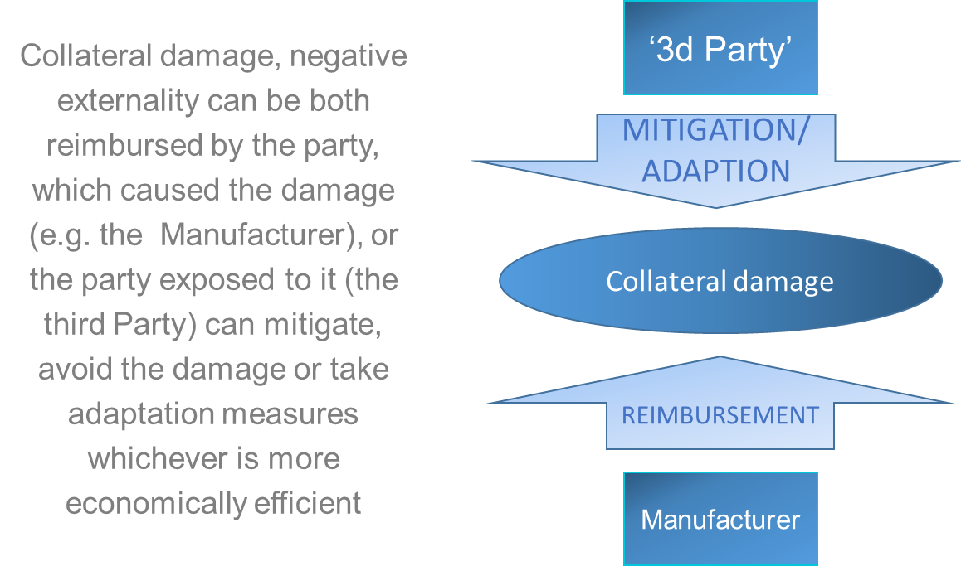
For example, the manufacturer produces gasoline with huge damage to the environment, natural resources, i.e. to future generations, and to the people’s health, security and quality of life. If the manufacture would have to reimburse all of the damage, prevent pollution, restore natural resources and environment, cover all related medical expenses, etc., the cost of production would increase dramatically, and he might even have to stop the production of goods demanded by people. However, if the third party, i.e. those who are aggrieved by the damage, take “adaptation measures” or measures to offset, mitigate the damage, costs might be even greater. Both of the solutions are equal and differ only by the level of costs.
With transfer of the entitlement for property, “the burden of the disadvantages”, i.e. responsibility for negative externalities is transferred to the buyer. The seller should inform the buyer of the risks and consequences associated with the goods transferred. Nevertheless, once the transaction is executed liability lies with the one who has acquired property rights.
The manufacturers argue that they supply goods and services in demand, which at least means that the buyer of the goods and services (the second Party) is equally liable. From the economic point of view, it is neither the installation, physical objects, nor physical processes, nor the ownership that causes damage. It is actually the transaction, the deal, the trade, which causes the damage, the negative externality.
Furthermore, if the parties agree on reimbursement from the manufacturer, the latter can reimburse negative externality (collateral damage) against the claim of the third party in monetary form, or the settlement may imply that either of the parties or professional supplier (the forth Party) provides for compensation (offsetting) or mitigation ‘in-kind’.
Figure 2 – Comprehensive peer-to-peer social cost problem solution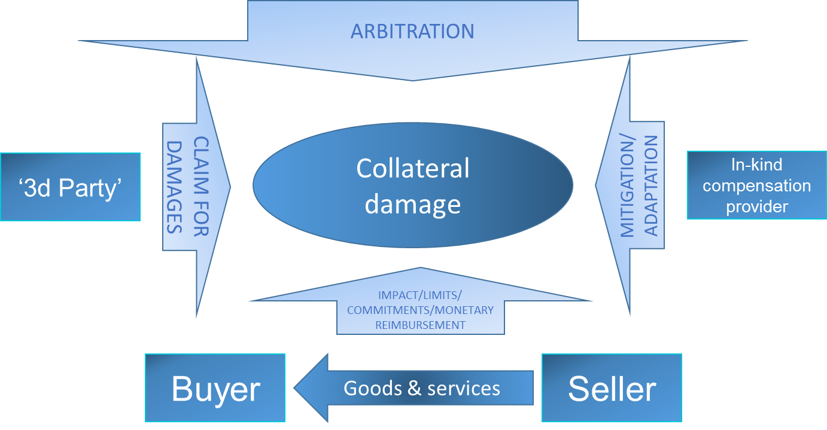
Traditionally, such complicated interactions of the four parties are regulated by the governments, which take possession of the arbitration, assign taxes and fees, quantitative limits and commitments.
In the example with gasoline, the damage is partially controlled by the government, which applies licenses, taxes, fees, penalties, and technical regulations. As a result, the government awards the manufacturer with indulgentia, and the latter transfers the liability to the car owner. The third party, those who are aggrieved by the damage, may try to seek reimbursement, which would be difficult as the manufacture has already acquired legitimate clearance from the government, or take measures to offset, mitigate the damage or adapt to it or take no measures at all (which is the less evil than the interference of the government).
Experience shows that government “corrective” interventions often do not resolve but aggravate problems while blocking alternative ways for optimal settlement. This leads to the need to “correct corrective interventions” and governmental activity starts to circle without positive results with great transaction costs for society.
In fact, solution may be found if there is no government or any “superior authority” action, only if the parties interact on decentralized peer-to peer basis.
The goal is to arrange for or create low transaction cost institutions to promote settlement between the parties via smart contracts without government interventions. That is where the governments could help: in supporting the creation of such institutions. F.A. Hayek noted that “compared with this method of solving the economic problem – by decentralization plus automatic coordination through the price system – the method of central direction is incredibly clumsy, primitive, and limited in scope”.
The advance of public and programmable blockchain technology, Turing complete systems, and triple-entry accounting, allows for decentralized arbitration and truly peer-to-peer settlement, and thus allows for further development of the Coase paradigm embracing all of the four parties involved excluding superior authority or allowing the parties to choose the medium.
Blockchain technology can be applied to mitigate collateral socioeconomic damage caused by economic activities; it requires market-based infrastructure that supports decentralized peer-to-peer interactions, the public network evaluation of negative impacts, the distribution of liability, and settlement by means of mitigation instruments. DAO Integral Platform for Climate Initiatives (DAO IPCI) is the public blockchain institution to perform the task.
There are no technical restrictions as to who may launch an autonomous mitigation program in DAO IPCI. Existing mandatory or voluntary, large and small programs of diverse scopes of activities and jurisdictions, as well as businesses, NGOs and even individuals may create independent decentralized autonomous organizations (DAO) to implement specific programs and projects and perform transactions in DAO IPCI. Independent mitigation programs within DAO IPCI may interlace and form a web of DAOs that share selected modules and protocols with their peers.
Furthermore, as costs are subjective in nature and are determined through aligning or juxtapositioning values of the parties involved, a decentralized peer-to-peer approach is necessary for the evaluation of the costs of negative impacts and mitigation benefits even if objective quantification is applied.
The most prominent instance of collateral socio-environmental damage created by economic activities are global environmental risks and climate change-related threats, which affect the health and well-being of individuals, create physical risks, financial, liability and regulation risks for businesses, and further to displacement of vulnerable populations due to sea level rise, natural disasters, impacts on agriculture and water supply from drought and heat waves, etc.
The public is aware of these problems, and individuals and businesses desire to support various projects offsetting environmental damage, there is a demand for such project results. However, the projects and their outcomes are sought to be independently verified quantified commitments-based and result-based.
The challenge of mitigating climate change is universal across the globe and in many respects is most simple case to refer in terms of mitigation of collateral socio-environmental damage of economic activities. The limited resource of the rights to economic activities harmful for the climate is quantifiable, universal and essentially fungible.
Climate change is a global issue with multiple and extremely diverse sets of “interested parties” or stakeholders, and can be resolved only on decentralized and public basis. Market instruments to mitigate climate change risks and damages are developing around the world and include the UNFCCC Paris Agreement concept of ‘internationally transferred mitigation outcomes.’ Though all carbon units essentially represent a right to emit one ton of carbon dioxide equivalent (CO₂e), regulatory, legal, commercial and trade, transactional, interjurisdictional barriers reduce their fungibility, which gravely affects their economic and environmental efficiency. There has been no “common space fabric” or financial instrument and ecosystem that would be universal, easy-to-use, transparent and reliable. Ideally, such an ecosystem would allow diverse stakeholders, governments, civil society, businesses and individuals to truly and directly participate in mitigation activities, to register quantified commitments, to invest environmental damage mitigation projects, to offset their carbon footprints, and to acquire and trade mitigation rewards. In a way, we may define the UNFCCC Paris Agreement as a ‘global climate policy interaction protocol’ addressing this issue.
One of the main barriers to the introduction of environmental markets, especially decentralized peer-to-peer schemes, is inertia of the existing environmental regulatory mechanisms, "rut" thinking, corporate interests, and "the evil you know is better than the evil you don’t" concept. John Palmisano, the architect of the first in history emission trading scheme, pointed out “existing system, with all of its imperfections, was at least understood and capable of being manipulated by learned and skilled industry and regulatory professionals”. “Fundamental rationale for emissions trading is that industry does not need to be told how to achieve inexpensive emissions reductions; industry only needs to be given the freedom to develop these reductions in a way that assures positive environmental outcomes”. When administrative regulation is substituted by market, many employees of government and corporate environmental agencies might face the need to retrain or even the threat of losing their jobs and their solidarity in opposition to the new model is quite understandable.
The opposition to blockchain incarnation of market models and concepts is even more evident. Blockchain solutions, which are decentralized and transparent, would be disruptive to the businesses of registries, brokers and for many of the regulatory functions.
A market-based approach is fundamentally quantity and resource-based. Once the resource is capped and quantified, self-executing algorithms are applicable substituting many of the regulatory functions such as establishing specific restrictions and technical parameters for each source of pollution. Consequentially, it would seem feasible for the partisans of market approach to focus on opportunities derived from the development of “quantified greenhouse gas emission limitation and reduction commitments” model.
According to the Intergovernmental Panel on Climate Change, limiting the warming caused by anthropogenic CO₂ emissions with a probability of >33%, >50%, and >66% to less than 2°C since the period of 1861–1880, required cumulative CO₂ emissions from all anthropogenic sources to stay between 0 and about 5760 GtCO₂, 0 and about 4440 GtCO₂, and 0 and about 3670 GtCO₂ since that period, respectively. An amount of 1890 [1630 to 2150] GtCO₂ has been already emitted before and by 2011. Therefore, to provide an acceptable level of risk mitigation, the volume of future emissions since 2011 should stay within approximately 750 GtCO₂. Similarly to other scarce natural resources, the more we emit, the more expensive it gets, and the more costs we bear.
Thus, for the year 2017, a conservative evaluation of the anthropogenic GHG emissions budget left would be 600 GtCO₂.
Within the time-space dichotomy of the party, which causes the damage, and the party, which suffers the damage, on the space scale, there are countries that are presumed to bear most responsibilities for accumulated damage and countries presumed most vulnerable to the damage. On the time scale, there are forthcoming generations presumed most vulnerable. The global resource of carbon emissions rights is limited and belongs not only to current owners of the sources of emission or those most vulnerable to the damage caused, but to forthcoming generations as well. Moreover, future generations are the party to suffer most damage. Under quantified commitments-based market system property rights should be assigned to the party, which values them most. Therefore, the market design should provide for the interests of forthcoming generations by long-term budgeting of the resource and probably by development of specific long-term market instruments.
Global coverage of quantified commitments-based programs with the launch of South Korea ETS has reached 4.6 MtCO2 in 2015, and with the launch of nationwide ETS in China might be close to 7 MtCO2 in the end of 2017, while annual global emissions remained at approximately 32 GtCO2.
Quantified greenhouse gas emission limitation and reduction commitments and commitments-based long-term budgeting of emissions are fundamental for environmentally sound mitigation policy.
Wide variety of existing forms of climate commitments, contributions makes them difficult to evaluate by universal scale and is a barrier for interaction, linkage of programs and fungibility of instruments (units) that are critical to ensure global mitigation effect.
Only quantified greenhouse gas emission limitation and reduction commitments and quantified commitments-based compliance units are inherently fungible on global scale.
The property rights issue should be resolved to provide for compliance units to become tradable. With the property rights explicitly or implicitly established creation of the market for carbon compliance units, representing rights to emit CO2, becomes possible. Yet, markets do not arise as natural phenomenon. They can only be created by human efforts, which could emerge either successful or failed.
Theoretically, it would be just natural and logical for the ‘peers’ to formulate fair method of allocation of the resource. The starting point, the baseline could be natural rights of ownership of the resource. For emissions markets the principle is known as “grandfathering”. It is consistent with liberal economic principle of allocation, one of famous historical examples of the application of which is Homestead Act in 1862 in the United States.
In accordance with such Homestead Principle, the resource is distributed on the grounds of claims, though in limited quantity, and assignment of its share to particular owner is subject to efficient and careful exploitation. Thus, it is particular business, enterprise, the company itself, which is interested to claim a certain portion of the resource, to claim specified amount of annual greenhouse emission rights, and to justify the claim by efficient exploitation of the resource.
Capping pollution does not necessarily means establishment of specific amount that can be emitted within a certain period. Emissions can be limited by the existing level, by prohibition of increasing the amount of emission from existing sources and of launching new sources without offsetting.
The most reliable way to achieve reductions and receive credits is by shutting down an existing source or permanently curtailing production or operating hours below that which existed at the time the new source application was submitted.
DAO IPCI Minimum Viable Product (MVP) is in place and provides for issuance, transfer, trading and retirement of the tokens representing mitigation instruments, carbon credits or quotas in the first place.

Concept design
DAO IPCI is not a mitigation program per se. It is a digital ecosystem, a platform addressed to any self-sufficient and responsible person actually willing to implement his programmatic market ideas on blockchain.

DAO IPCI design objective is to provide any person, program, corporation, association or jurisdiction, with common space fabric, common tools and ecosystem that is universal, reliable, transparent and that allows diverse stakeholders, including businesses and individuals to: register their quantified impacts and emissions reductions pledges; invest in mitigation projects; offset environmental footprints; acquire and trade mitigation instruments; join existing or launch new programs.

DAO IPCI is smart contracts-based digital environment developed to minimize transaction costs, to make issuance and transfer of mitigation units, including internationally transferred mitigation outcomes, highly reliable, transparent and centralized manipulations-proof.

Balance of self-sufficiency, decentralization and environmental integrity of the ecosystem is an intrinsic principle of critical importance.

DAO IPCI Minimum Viable Product is free, open-sourced, i.e. can be used and improved by anyone without restrictions or fees, and provides for mitigation of collateral damage by means of offsetting (compensation) by mitigation instruments and transparent accounting of mitigation activities.

The first version of DAO IPCI inter alia allows participants to participate in greenhouse gas (GHG) credit-based or quota-based emissions trading schemes to account for claims made towards these targets.

The protocols designed for article 6 of the Paris Agreement and for CORSIA specifically exclude possibility for double counting of mitigation outcomes for private use and for performance under NDCs.

There are no technical restrictions as to who may launch an autonomous mitigation program in DAO IPCI. Existing mandatory or voluntary, large and small programs of diverse scopes of activities and jurisdictions, as well as businesses, NGOs and even individuals may create independent decentralized autonomous organizations (DAO) to implement specific programs and projects and perform transactions in DAO IPCI. Independent mitigation programs within DAO IPCI may interlace and form a web of DAOs that share selected modules and protocols with their peers.

Diverse mitigation instruments (environmental units) are represented by specific tokens issued via coordinated actions of the Operator of the DAO, the Issuer and the Independent Entity. Only if these actions are in coordination and in compliance with the logic of the open-source smart contracts may the tokens be issued to the possession of the Issuer.

Independent Entities play a crucial arbitration role in the procedure. To reduce transaction costs and convert arbitration to truly decentralized smart contracts based model, IoT smart devices and Network verification has to be introduced and developed to substitute gradually “manual verification”.

Figure 3 – IoT smart devices based verification of renewable energy based credits (Prototype)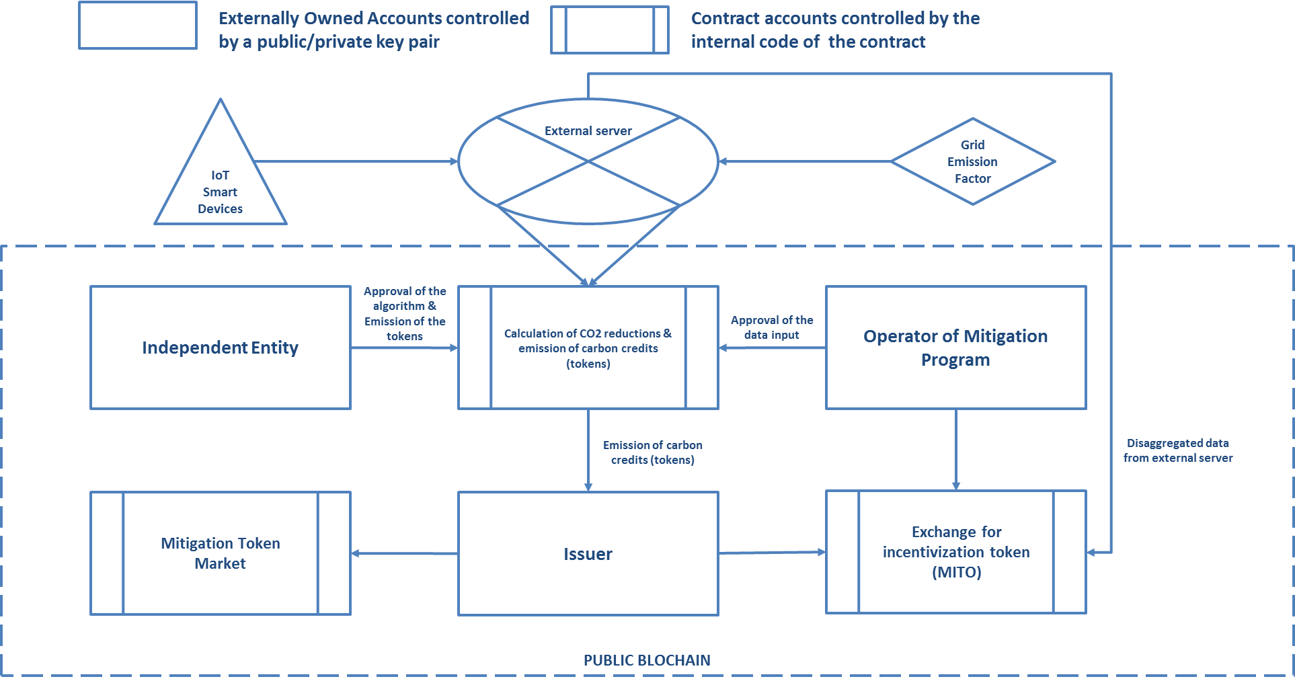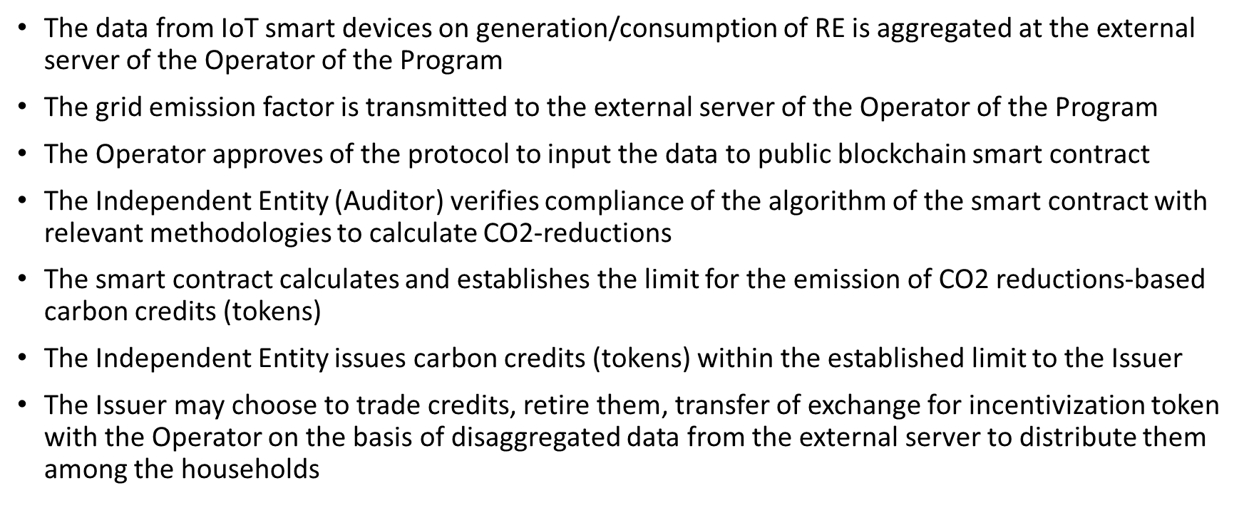
Similar scheme would be used for issuance of tradable tokens representing renewable energy generation or consumption. Once we assume that renewable energy generation brings mitigation benefits and can be quantified in Watthours, corresponding mitigation instrument (token) would represent positive externalities associated with generation of specific amount of energy by renewable sources.

IoT devices and Artificial Intelligence and their economic interaction, ‘Robonomics’, are the future. The interesting question is how exactly artificial devices would participate in human-to-machine deals, transactions, which need a common algorithm for market price. An algorithm based on ‘marginal cost’ concept may be introduced for machines, while human individuals would still and ever use subjective values to determine prices and costs. DAO IPCI concept design implies the development of a system for human-to-machine and machine-to-machine interactions to work in a fully self-executing mode.

Regular demand for tokens representing mitigation instruments is on the side of the participants of commercial deals that cause collateral damage, manufacturers, suppliers and consumers, sellers and buyers of goods and services. However, monetary claims for damages of the third Party is also a potential source of demand, which can be satisfied either in monetary form or by ’in-kind’ offsetting. Existing smart contracts allow for initiating claim for damages, and supporting it by secondary claimants, reimbursement or offsetting the damage.

There are notorious examples of public protest in Russia against air pollution from landfills. Little can be done as all the permissions from the government are in place. Enlisting a claim against landfill owners or/and relevant authorities in DAO IPCI is an alternative peer-to-peer way to seek settlement. Primary individual claim secured by MITO deposit might be supported by secondary claims increasing the value of the claim. Furthermore, objective IoT devices may quantify and verify negative impact. The Respondent may choose to ignore the claim, reimburse damage by buying out “the claim tokens” or to compensate the damage with the verified results of mitigation measures if there are any.

Figure 4 – 3d Party Claim for Damages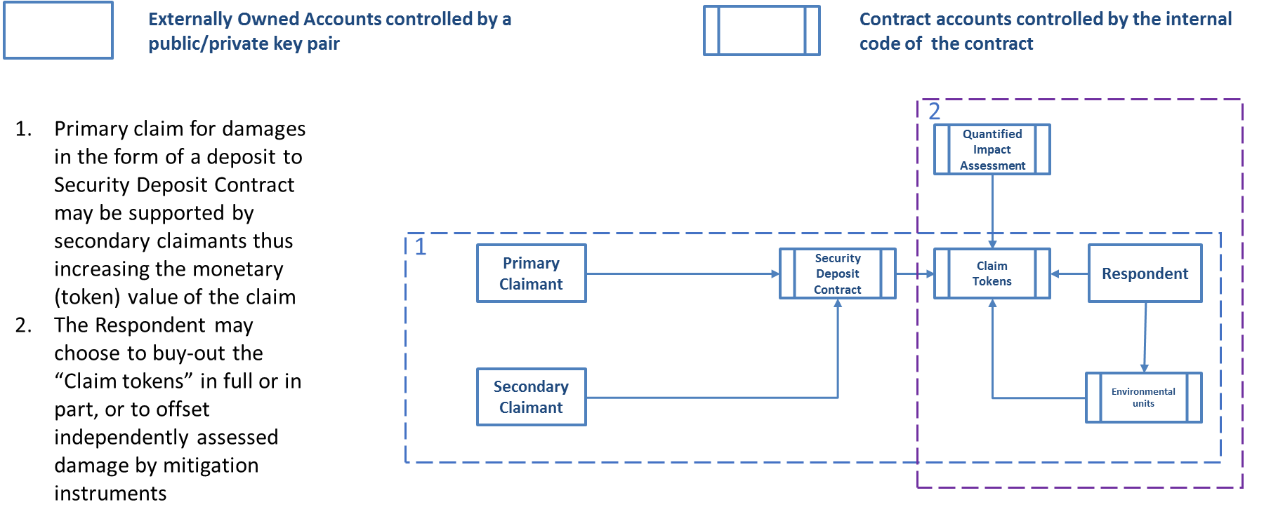

IoT sensors deployed on drones are under field tests to comply with measurement standards and requirements. On-site monitoring of ambient pollution parameters would be available for anyone to order via DAO IPCI blockchain with the monitoring results uploaded to public distributed file storage.

Other than tokens representing mitigation instruments type of token, represents an internal currency for internal markets of independent programs, essentially a payment/utility token. Operators of independent programs, DAOs, may issue this type of tokens arbitrarily.

Fundamental concept for issuance of independent currencies is that artificial state monopoly for money emission suppressing other currencies is harmful in respect of inflation, social conflicts, unrestrained budget expenditures, economic nationalism. Government monopoly for money should be abolished. From the very beginning blockchain technology and its first manifestation, Bitcoin, brought to life a simple though disruptive concept: that anyone can issue his own global money with minimum transaction costs. Actually, monopoly for money by the governments has already ended, and denationalization of money has begun. Suppression by the governments of currencies issued by entities, persons or even machines, is hopeless, does not make sense and will eventually stop. At the end of the day, it is up to person himself to choose which of the currencies to use for each specific exchange or to store values. On the other hand, it is up to the Issuer to choose the scheme of issuance of “his money”. However, “one-time” sale of the token representing the currency is not the only option. Proof-of-Work algorithms to issue currency with all the benefits, unfortunately, are not a market feature. Proof-of Stake also do not fully reflect market demand for the token. Alternatively, a mechanism based on market demand for the token may be created. For this purpose initial crowd-offering should be targeted at understanding the initial demand and initial level of price acceptable for different buyers however unpredictable those might be. A permanent emission mechanism can be launched on this basis. For example, a contract that offers issuance of new tokens at the Ceiling price. When there is enough data from the smart-contract accumulated, Artificial Neural Network may take over setting the contract price for the token issuance. This way the Issuer provides options to the Buyers whether to use the token on the Market to buy goods, to buy more tokens, to store for the future or to go to an external exchange.

Market is the core element of DAO IPCI structure and of any independent program, DAO, within the ecosystem. Other elements like issuance or retirement of mitigation instruments provide for the quality of market goods and traceability of transactions, compliance with the program requirements. The goods traded at these markets are not for direct consumption but are goods of a higher order, factors of further production; essentially, they represent rights for further economic activity harmful to a third party. It is in the best interests of all DAO IPCI stakeholders to link, integrate and merge markets, and therefore to have a unified payment token.

Payment token functional role is to provide for seamless market operations, fungibility of mitigation instruments, and its’ value is determined market demand for the token. To provide for market operations with minimum transaction costs and for growth of value of the market further emission of payment token would seem necessary. However, payment token emission algorithm has to be compliant with inherent properties of public blockchain.

“The state of the market at any instant is the price structure, i.e., the totality of the exchange ratios as established by the interaction of those eager to buy and those eager to sell.” Evaluation of the state of the market might be performed by verification nodes of the programmable blockchain Network. Or, market evaluation of the token should be introduced. Based on this evaluation, emission of payment token algorithm should be introduced to support ‘proof-of-stake’ protocol.

Figure 5 – The Market and Issuance of Payment Token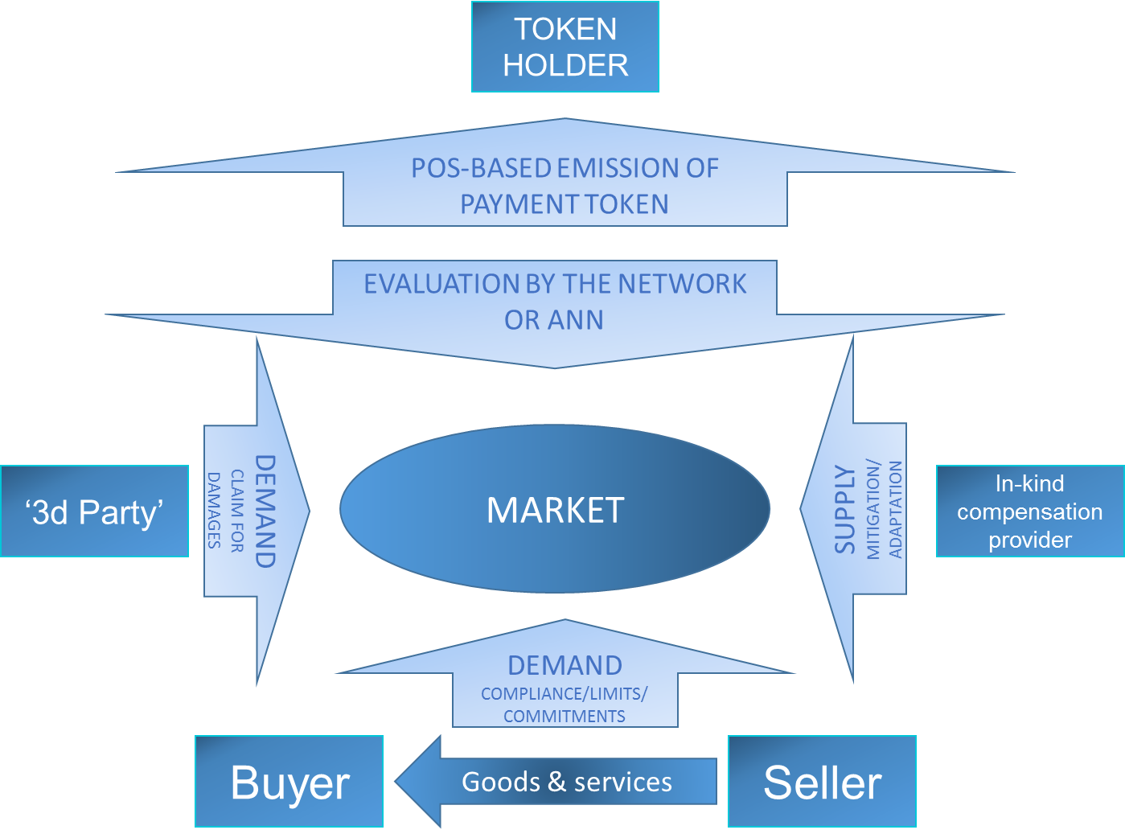

There is a dominant economic idea that the supply and demand and turnover determine the value of the market and are to be used to determine the amount of the emission needed. However, the fundamental parameter still is the market demand for the token, whether it is used to exchange for goods (mitigation instruments) available at the market, or to store value on the balance.

Most of the elements to implement the model in principle are in place in DAO IPCI. Yet, some of them are still under development. What is far more important, the concept in general still needs comprehension by the “climate” and “blockchain” communities. The concept that there is no governance or central authority, which prescribes solutions, restricts or allows action, is still making its way even in public blockchain projects.

Attempts to create carbon emissions-related blockchain systems and cryptocurrencies would fail if they lack of high quality underlying to support them. DAO IPCI essentially excludes emission of cryptocurrency, and is based on the independently assured assets, including climate change mitigation instruments in the first instance, as the underlying.

Blockchain-based mitigation concept allows for the same protocols to be applied to other than climate change-related impacts, commitments, assets, rights and liabilities. Digital ecosystem is designed to offset collateral damage of economic activities by means of ‘physical’ or monetary instruments.

DAO IPCI is designed to be truly decentralized public blockchain-ecosystem and aims at creation of common business space to attract financing from investors not limited by financial capacity, location, or legal status with minimization of transaction costs, increased reliability and transparency of the whole process, which would be free of interference, interventions, manipulations or falsifications. The blockchain system as a whole is relatively immune to political, administrative, regulatory interventions of the governments. The open source code provides for securing fundamental requirement – minimum need for trust.

Furthermore, DAO IPCI architectonics provide for actual interaction of different asset-based systems on the Ethereum blockchain. The modules of external blockchain systems, DAOs, e.g. energy assets-based, may be included into DAO IPCI Core, and reflected in the decentralized application, and vice-versa.

Figure 6 – DAO IPCI architectonics 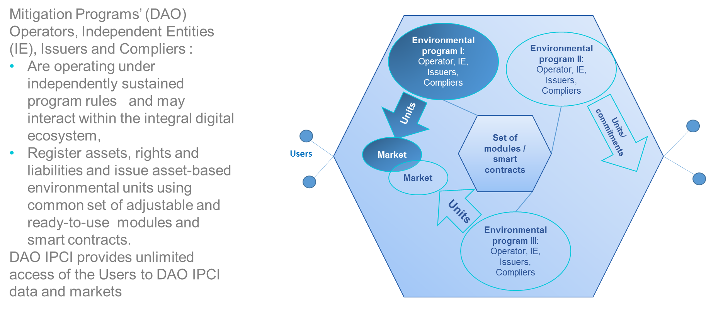

Participants, Mitigation Programs and Environmental Units, Functional Modules and Operations
DAO IPCI stakeholder may choose either to join existing programs as user, issuer, complier or independent entity or to launch new program (DAO) undertaking the functions of the operator for such new program.

DAO IPCI stakeholder may join existing program to
- perform as Issuer to supply environmental units
- perform as Complier to comply with particular mitigation policy, for example to offset carbon footprint
- trade environmental units to support mitigation projects as User
- provide professional services as an Independent entity

DAO IPCI stakeholder may launch new program by
- creating DAO
- setting the rules of the new program
- bringing in and accepting issuers, independent entities, compliers and users to perform under the new program.

Rules and requirements of the programs include standard elements: regulator (operator), verification by independent entities, limits, validity periods, tools to cover risks, market institutions (trading) etc. DAO IPCI provides these standard elements with integral system of smart contracts, adjustable for specific program requirements.

Environmental units (asset-based tokens) represent the main instrument of the programs in DAO IPCI. Various environmental units are issued in DAO IPCI blockchain under rules and requirements of specific programs. These programs may include: mandatory, voluntary and pilot environmental market programs, emission (or effluent) trading schemes, cap-and-trade programs, offset credit, carbon tax credit-based and hybrid programs, renewable standards and renewable energy certificates-based programs, other social costs mitigation market-based programs.

Environmental units are generated in accordance with strictly structured procedure and distributed functions of the Issuer, the Operator and the Independent entity.

Environmental units are issued to DAO IPCI blockchain:
- Directly to the Issuer subject to program Operator’s approval on the grounds of verification by Independent Entity,
- On the grounds of the program Operator decision to accept environmental units issued by alternative programs and accounting platforms in their original form or to convert and exchange such units for the program units subject to compliance with the program requirements and criteria and confirmed cancelation of alternative registry entries and units turnover,
- Under collateral secured at the Security deposit contract.

Issuance of environmental units via Security reserve contract requires to reserve specific share of the units for specific period, established by the Operator on the grounds of independent assessment of related risks. The units would be burnt (retired) in case they are recognized as void, so that total amount of digital environmental units issued to the platform would in any event be equivalent to underlying. After the reservation period is over the units are returned to the Issuer’s account. Security reserve contract may be used to withhold environmental units in order to avoid or correct input issuance data mistakes.

DAO IPCI current procedure to issue assured or verified environmental mitigation units includes the following coordinated steps by the Issuer, Operator and Independent entity:
- The Issuer creates registry for particular units and security reserve or security deposit contract, assigns Independent entity
- The Operator adds registry and contract to DAO Core, and lists the Independent entity
- The Operator sets limit, validity period, security deposit contract parameters
- The Independent entity sets reservation period and percentage
- The Independent entity issues verified units or units secured by collateral deposit and transfers them to the Issuer.

The units then can transferred, traded or used for compliance, i.e. retired.

Figure 7 – Issuance of the tokens representing mitigation instruments (environmental units)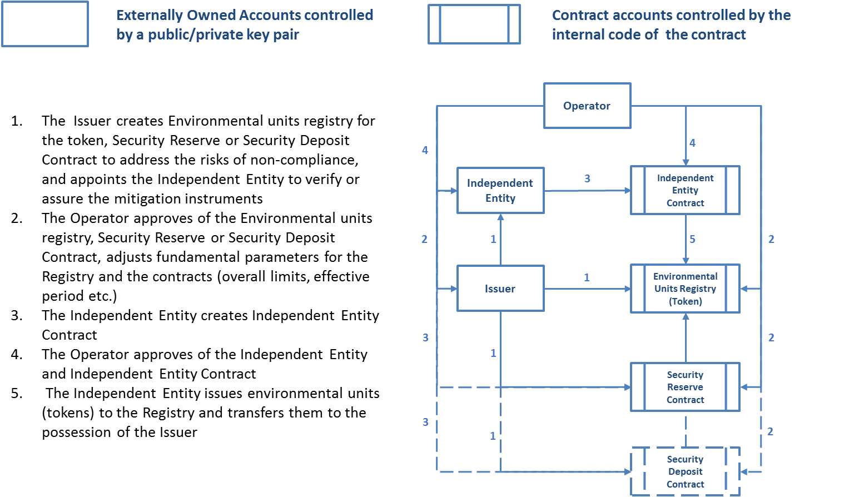

Apart of the environmental units’ issuance protocol, the following DAO IPCI modules and operations are in place:
- Transfer of the units,
- Burning (retirement) of the units for compliance, e.g. to offset specific goods and services carbon footprint, at the Complier contract,
- Reservation, return and withdrawal of the units withheld at Security reserve and Security deposit contracts,
- Placing and executing sell/buy orders at MITO Market,
- Uploading the documents to IPFS to confirm and justify transactions,
- Optional identification of the agents (program participants),
- Tracking transaction history (log).

DAO IPCI offsetting carbon footprint scheme
Collateral damage of production, consumption, transaction of goods and services has become crucially important competitive factor, and mitigating this damage is now customary for many market activities. Offsetting carbon footprint scheme ensures irreversible burning of the units at the Compliers contract.
Offsetting carbon footprint functional scheme and further development (Figure 10):
- Supplier of goods and services provides Consumer with verified data on carbon footprint (amount of CO2e) of the goods and services acquired under specific deal
- Consumer acquires the correlated amount of carbon units at DAO IPCI from Issuer or holder of the units
- The units are transferred to the Burning Contract address
- Supplier requests/receives reports on relevant carbon footprint offsetting operations.

Figure 8 – Offsetting carbon footprint scheme 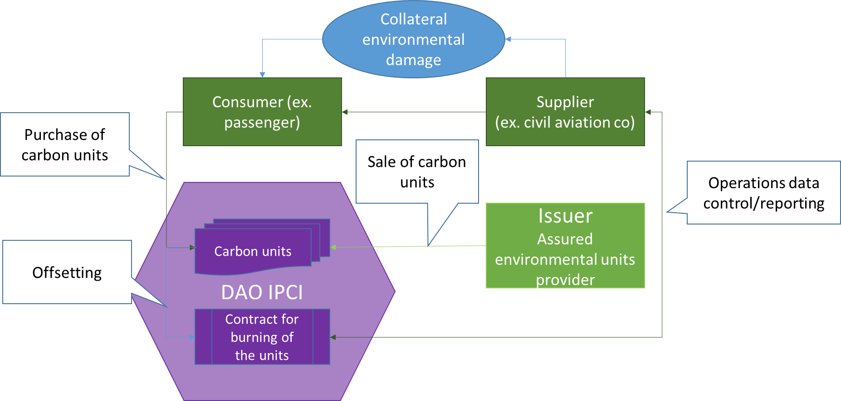
Further development implies introduction of accounting and offsetting of scope2 and 3 ‘upstream’ and ‘downstream’ impacts.

Figure 9 – Offsetting carbon footprint scheme development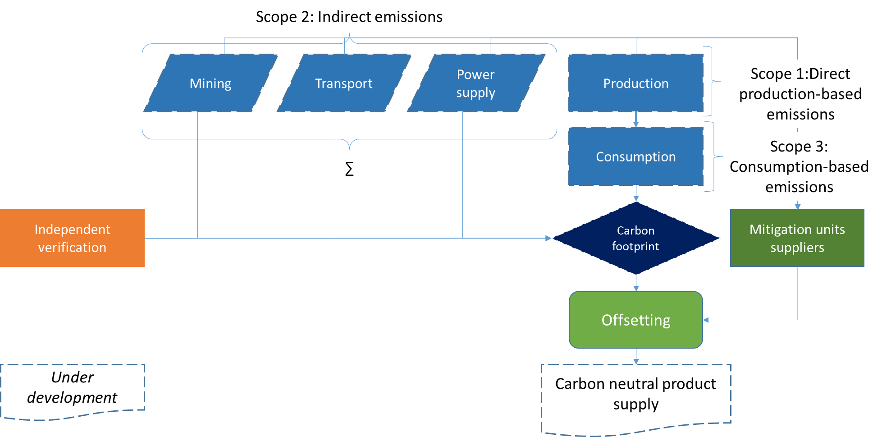

‘Blockchainization’ of the Paris agreement
Article 6 of the UNFCCC Paris agreement has actually established global market-based interaction protocol for climate change mitigation programs and activities. DAO IPCI concept design provides digital environment to execute this protocol.

To ‘blockchainize’ article 6 of the Paris agreement, the following design has been developed with most of the modules and smart-contracts needed already in place:

Paris Agreement | DAO IPCI Blockchain Ecosystem
Article 6 | DAO Core/Modules
Parties voluntary cooperation
1. Parties recognize that some Parties choose to pursue voluntary cooperation in the implementation of their nationally determined contributions to allow for higher ambition in their mitigation and adaptation actions and to promote sustainable development and environmental integrity. | ‘Quantified Commitment’ and ‘Quantified Impact’ Module  Nationally Determined Contributions (NDC) should be reflected as ‘Quantified Commitments’ and ‘Quantified Impact’. | Creation of ITMO Market Module by UNFCCC Secretariat. Creation of independent DAOs of the Parties  Parties that have chosen to pursue voluntary cooperation create independent Operators DAOs with common market created by UNFCCC Secretariat for all Operators, which chose to cooperate.
2. Parties shall, where engaging on a voluntary basis in cooperative approaches that involve the use of internationally transferred mitigation outcomes towards nationally determined contributions, promote sustainable development and ensure environmental integrity and transparency, including in governance, and shall apply robust accounting to ensure, inter alia, the avoidance of double counting, consistent with guidance adopted by the Conference of the Parties serving as the meeting of the Parties to this Agreement. | Issuance of environmental units via Security Reserve or Security Deposit Contracts  Common market token is an ‘Internationally transferred mitigation outcome’ (ITMO).  Once issued ITMOs are deducted from respective Party NDC, which arithmetically means increase of Quantified Impact and decrease of mitigation contribution (Quantified commitment) by the amount of tCO2e reflected in ITMO.  Issuance of ITMO may be performed only by the Independent Entity and only to the address endorsed (listed as Agents) by the respective Party Operator.  Double-counting is avoided, transparency ensured by inherent properties of public blockchain.  Respective Party Operator and Independent Entity are responsible for compliance of ITMOs with sustainable development and environmental integrity principles.
3. The use of internationally transferred mitigation outcomes to achieve nationally determined contributions under this Agreement shall be voluntary and authorized by participating Parties. | Complier Contract  Authorization of private use (transfer or trading) of internationally transferred mitigation outcomes is provided and ensured by the protocols for Issuance of ITMO (see p.2). Privately used ITMO are not counted as contribution of any Party to the Agreement.  Use of ITMOs for to achieve NDC may be used only via respective Party (Operator) Complier Contract(s). Only the units ‘burnt’ (irrevocably retired) at specific Compliers’ Contract(s) may be counted as additional contribution.
Sustainable Development Mechanism
4. A mechanism to contribute to the mitigation of greenhouse gas emissions and support sustainable development is hereby established under the authority and guidance of the Conference of the Parties serving as the meeting of the Parties to this Agreement for use by Parties on a voluntary basis. It shall be supervised by a body designated by the Conference of the Parties serving as the meeting of the Parties to this Agreement, and shall aim: | Creation of independent DAO (Operator).  Creation of the List of Independent Entities (ACL Storage).  Creation of SDM Token Market  UNFCCC body designated by the Conference creates DAO (Operator),  creates List of Independent Entities,  creates SDM token and SDM Market
(a) To promote the mitigation of greenhouse gas emissions while fostering sustainable development;
(b) To incentivize and facilitate participation in the mitigation of greenhouse gas emissions by public and private entities authorized by a Party; | Issuers addresses and contracts  The Operator shall approve the addresses (list as SDM Agents) and Issuers’ contracts only for the Issuers’ listed as Agents by respective Party Operator (see p.2 Issuance of ITMO via Security Reserve or Security Deposit Contracts above)
(c) To contribute to the reduction of emission levels in the host Party, which will benefit from mitigation activities resulting in emission reductions that can also be used by another Party to fulfil its nationally determined contribution; and | Complier Contracts  SDM tokens (emission reductions) shall be used by another Party to fulfil its nationally determined contribution via respective Party (Operator) Compliers Contracts. Only the units ‘burnt’ (irrevocably retired) at specific Compliers’ Contract(s) may be accounted to fulfill NDC. (see p. 3 Complier Contract above)
(d) To deliver an overall mitigation in global emissions. | Quantified Impact module  Emission reductions represented by SDM tokens should actually reduce registered quantified impact or restrain quantified commitments
5. Emission reductions resulting from the mechanism referred to in paragraph 4 of this Article shall not be used to demonstrate achievement of the host Party’s nationally determined contribution if used by another Party to demonstrate achievement of its nationally determined contribution. | Issuance of environmental units via Security Reserve or Security Deposit Contracts.  Quantified commitments and Quantified impact module  Once issued emission reductions (represented by SDM tokens) are deducted from respective Party NDC, which arithmetically means increase of Quantified Impact and decrease of mitigation contribution (Quantified commitment) by the amount of tCO2e reflected in SDM tokens.
6. The Conference of the Parties serving as the meeting of the Parties to this Agreement shall ensure that a share of the proceeds from activities under the mechanism referred to in paragraph 4 of this Article is used to cover administrative expenses as well as to assist developing country Parties that are particularly vulnerable to the adverse effects of climate change to meet the costs of adaptation. | Commission fees  Commission fees in DAO IPCI are established by independent Operators

Article 6 of the Paris Agreement implies two mechanisms issue and trade carbon offset credits: bilateral, analogue of the Kyoto Protocol Joint implementation and ‘centralized’ Sustainable Development Mechanism, analogue of the Kyoto Protocol Clean Development Mechanism. DAO IPCI provides for both mechanisms to be activated on the public blockchain platform.
Figure 10 – Paris Agreement Art. 6 bilateral mechanism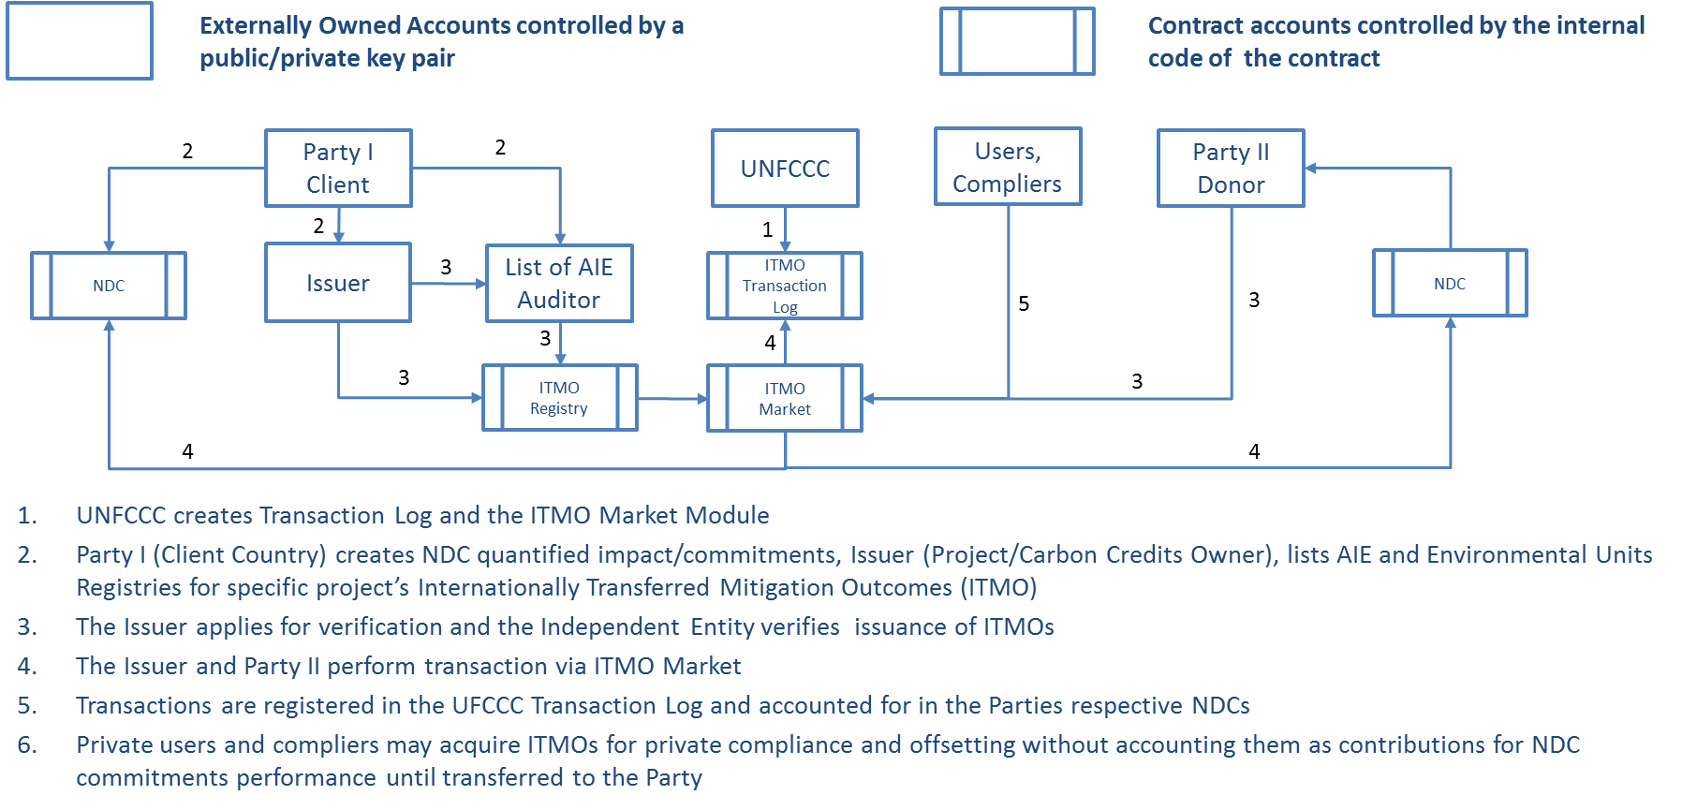
Figure 11 – Paris Agreement Art. 6 Sustainable Development Mechanism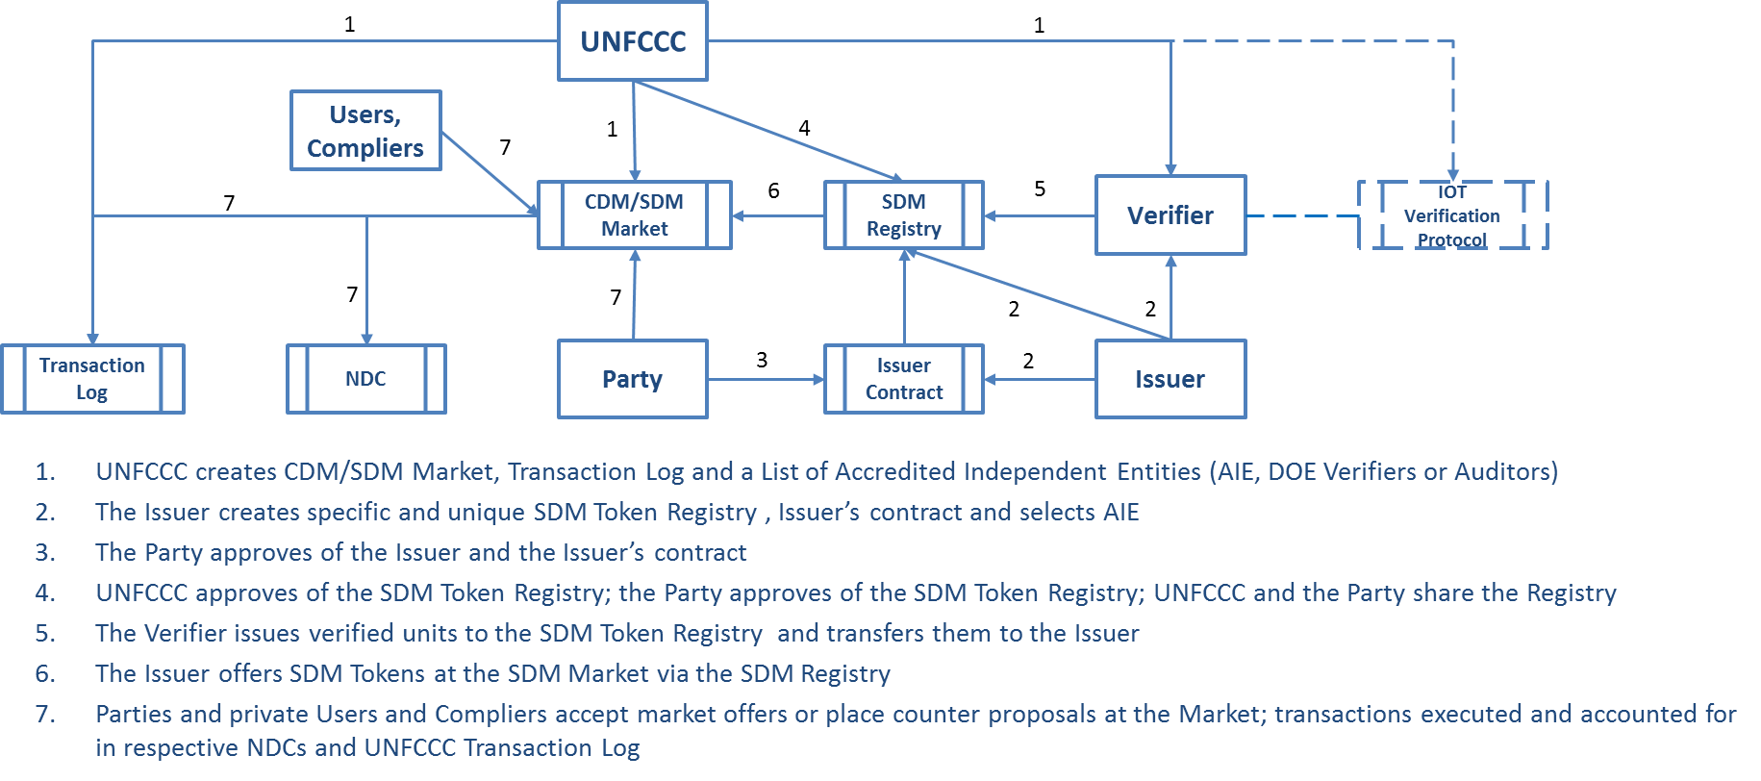

Scheme for Carbon Offsetting and Reduction Scheme for International Aviation (CORSIA)
Specific protocol for Carbon Offsetting and Reduction Scheme for International Aviation (CORSIA) has been developed and proposed for ICAO consideration.

Figure 12 – Registration and accounting for quantified impact/commitments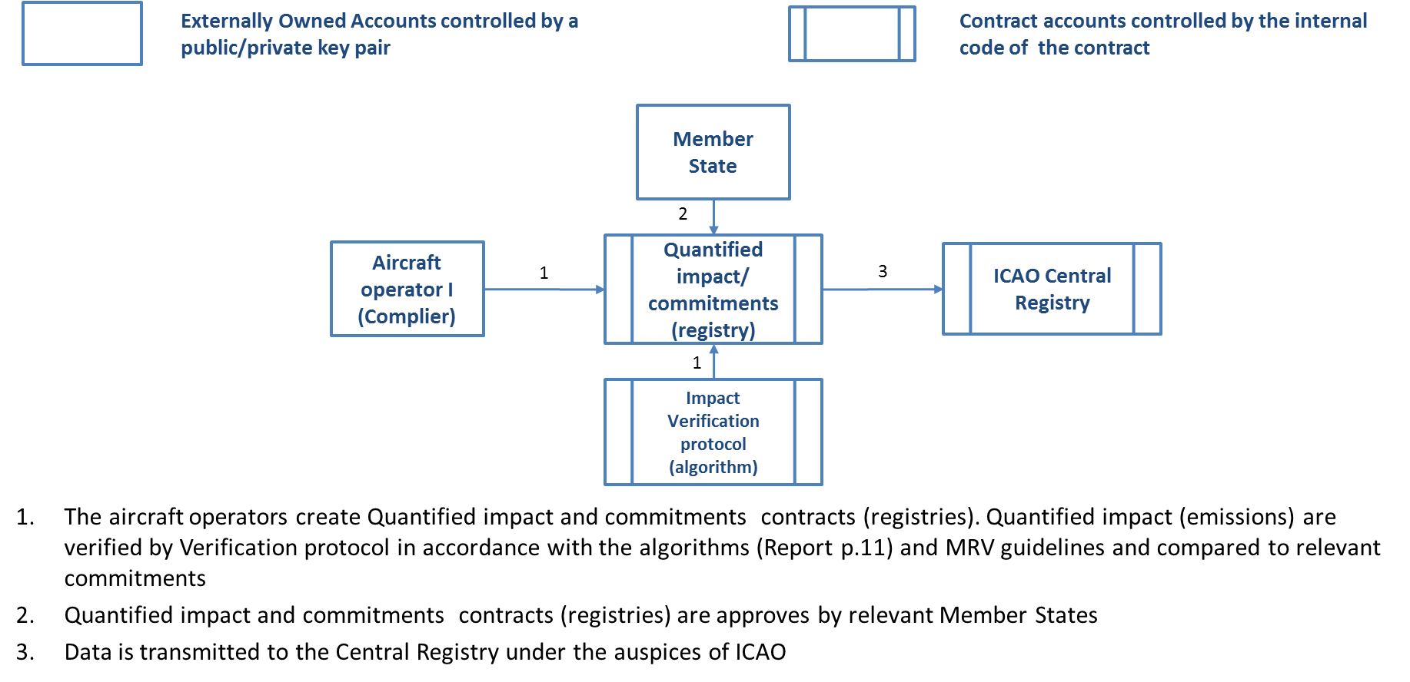
Figure 13 – Offsetting of quantified impact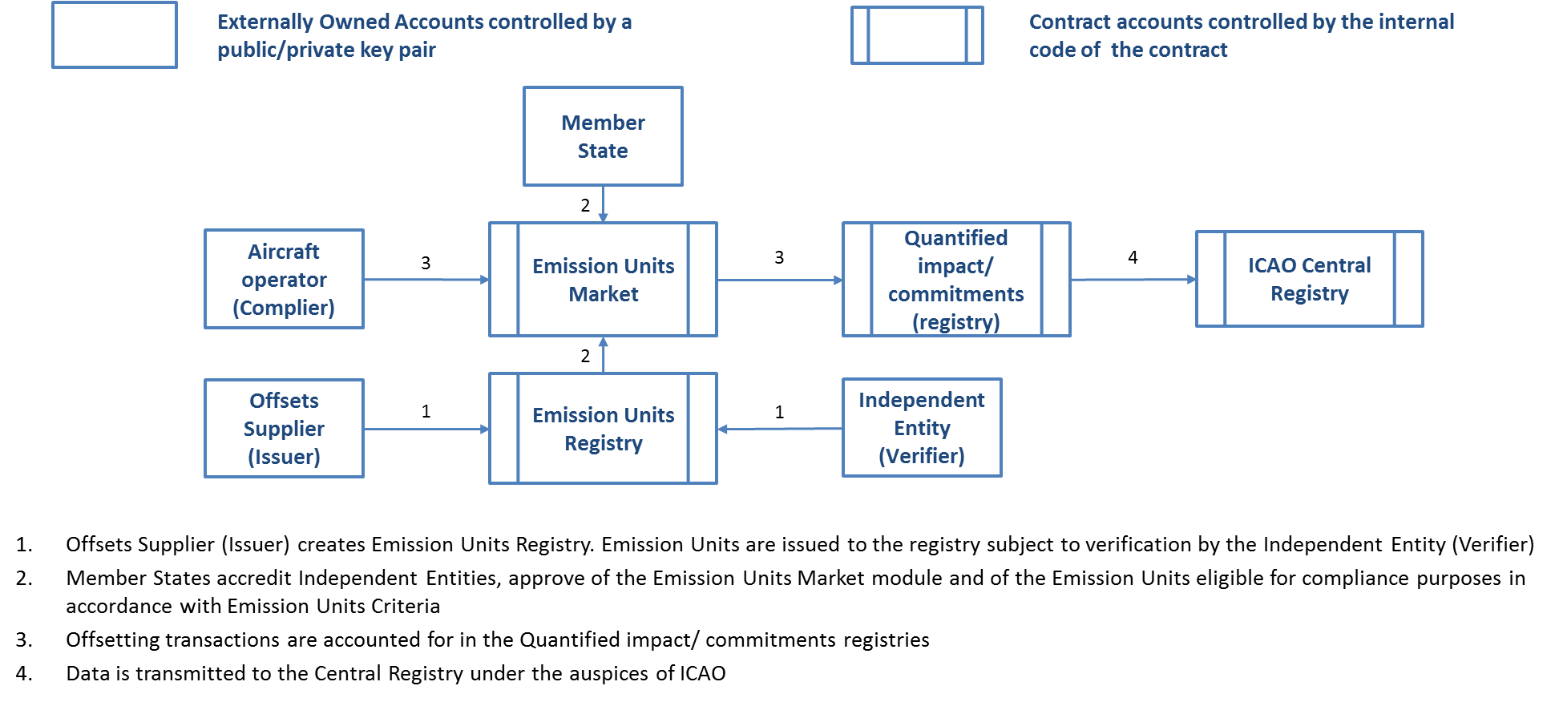

Mitigation Token
Mitigation Token (MITO) is digital currency, utility/payment token, which is intended to provide digital access to MITO Market. MITO is intended to serve for the purposes of exchange of numerous and diverse environmental units, natural capital asset-based tokens representing societal costs and mitigation instruments. Namely and in the first instance, GHG emission quotas and credits are the assets that become fungible via MITO and MITO market. Distinctive characteristics of the two types of DAO IPCI tokens are that only one of them, MITO, is an exchange vehicle, a payment token, digital currency while the rest of tokens represent diverse mitigation compliance units, environmental assets or natural capital assets as underlying. Other function of Mitigation Token is to serve as a collateral under the Security Deposit Contract, which allows for issuance of “provisional environmental units” prior to their verification.
Other than MITO tokens, i.e. environmental units, are issued not by DAO IPCI Founders per se, but by coordinated actions of issuers, operators and independent entities (see the section “Participants, Mitigation Programs and Environmental Units, Functional Modules and Operations” of the White paper).
As of now, May 2018, overall more than 1.6 million environmental units have been issued to DAO IPCI environmental units’ registries under two GHG emission reduction projects.
68 thousand Mitigation Tokens have been issued by the crowd-funding contract at the presale stage in September-October 2017, 42,000 MITO have been distributed to DAO IPCI advisors as 2017 annual remuneration, and the rest 8,958,000 MITO are held at the Congress contract of the Founders. No further emission of the same token is technically possible, as the ownership has been transferred to the crowd funding contract, which has expired on October 30, 2017.
Furthermore, mitigation compliance units like carbon emission quotas and credits, other emission or effluent credits, renewable energy certificates, and even quantified social benefits (‘environmental units’) are regulated by wide variety of programs, and in principle, nothing can prevent jurisdictions, entities, businesses, NGOs or individuals from launching new and independent result-based mitigation programs in DAO IPCI. Existing and newly launched programs may create ‘sovereign’ representations in DAO IPCI in the form of autonomies (DAOs). These ‘representations’ are encouraged to adhere to MITO as a market currency to ensure integrity and value of DAO IPCI network while maintaining decentralized nature of the blockchain ecosystem.
Only unregulated voluntary carbon credits are actually available at DAO IPCI for the moment and the perspective of having regulated carbon compliance units represented as tokens in DAO IPCI is still uncertain.
Mitigation Token is the key element to provide for transactions’ efficiency and integrity of DAO IPCI ecosystem.
Mitigation Token purpose is to provide MITO market exchange operations with environmental units issued to the environmental units’ registries by independent entities under the rules and supervision of mitigation programs’ operators.
MITO is inherently appropriate and designed for executing MITO Market smart contracts, including: environmental units’ buying and selling orders, payment of MITO market commission fee. MITO also serves as a collateral under Security Deposit Contract.
Genesis Operator and the Founders (see: ipci.io/team) have performed initial emission of Mitigation Token
- To distribute MITO token and provide for launch of MITO market,
- To boost non-commercial research and development of socio-economic and IT protocols needed,
- To sustain and expand DAO IPCI ecosystem,
- To provide for incorporation of legal entities for these purposes,
- To obtain legal and other professional expertise and services needed to support implementation.

DAO IPCI allows for creating independent markets for environmental assets, but this does not prevent the existence of a "default" market, which would be used as a guinea pig, i.e. the market with the boldest ideas from the community around the project. MITO would be the unit to which all trades in this market take place. Thus, MITO will be endowed with value functions. The most important in this case for value will be its autonomy, i.e. we issue MITO and ensure that it is not possible to influence its characteristics. Thus, MITO would become an autonomous value.
Carbon units for the development of IoT network must be traded to MITO. However, sensor networks involved in the generation of carbon units can also accept MITO to provide additional services to major market participants. For example, additional data measurements.
Looking forward to the update of the Ethereum network, in which it will be possible not to pay a commission in Ether, MITO would be used to pay for transactions via smart contracts that are developed and settled in Ethereum Blockchain by DAO IPCI. If we can get approval from the validators to process transactions in the common Ethereum network to our contracts without Ether fees, but only for MITO, then MITO will have a direct function of a protocol token.
Other than tokens representing mitigation instruments type of token, MITO represents an internal currency for internal markets of independent programs, essentially a payment/utility token. Operators of independent programs, DAOs, may issue this type of tokens arbitrarily.
There is a dominant economic idea that the supply and demand and turnover determine the value of the market and are to be used to determine the amount of the emission needed. However, the fundamental parameter still is the market demand for the token, whether it is used to exchange for goods (mitigation instruments) available at the market, or to store value on the balance.
Current Mitigation Token has been issued by the Genesis Program Operator, and further emission based on the demand for the token is technically impossible. Under the circumstances, it would be reasonable to design and execute the issuance and distribution of “MITO 2.0” token. It should be performed by “the Pool of DAOs”. MITO 1.0 should be exchanged to MITO 2.0 at the rate of 1:2 to fulfil the commitments to MITO 1.0 presale Buyers. To ensure the exchange “Alembic” or “Distillation” smart contract should work long enough to preserve the rights of MITO 1.0 presale Buyers.
Number of MITO 2.0 decimals should be increased to the level sufficient to support future hypothetical transaction fees, i.e. to the order of Ether decimals, and an emission mechanism designed. The ultimate target of the emission model is to provide for the growth of value of MITO Market and of MITO.
There should not be a monopolist, or a predesigned market maker.
The main question for MITO 2.0 is whether to issue fixed amount or design a token emission contract.
The following scheme is proposed for discussion.
Figure 14 – Emission of MITO 2.0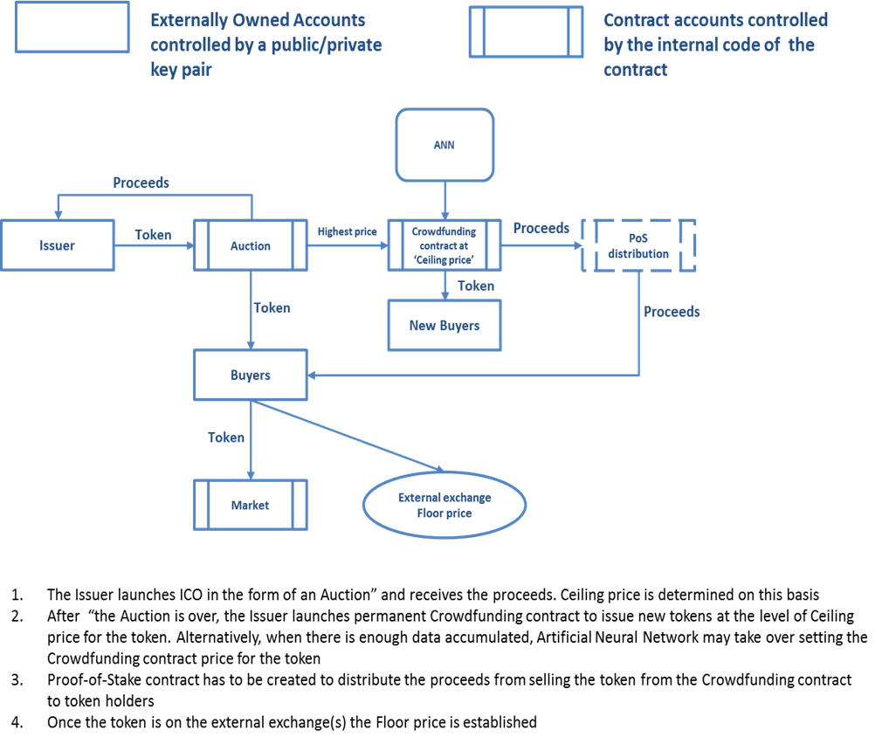
As newly issued tokens yield proceeds to the possession of existing token holders interested in the value of the market and the token, there would be an incentive to increase the value of the market and the demand for the token and no incentive to falsify trades in order to increase emission.
Most of the elements to implement the model in principle are in place in DAO IPCI. Yet, some of them are still under development, what is far more important the concept in general still needs comprehension by the “climate” and “blockchain” communities. The concept that there is no governance or central authority, which prescribes solutions, restricts or allows action, is still making its way even in public blockchain projects.

Prospects and plans of development
Long-term prospects of DAO IPCI development are limited only by its’ functional capacity as the trends are evidently in favor of environmental markets’ and specifically carbon markets’ expansion both in scale and number, linkage and integration with a perspective of ultimate creation of common market space with fungible instruments. DAO IPCI is a prototype of such market space and units.

While the initial objective is to provide existing markets with a ‘blockchain incarnation or ‘blockchain representation’, the goal is also to create a way for environmental markets to evolve toward truly decentralized and free personal market choice model.

Near-term prospects rely on primary demand development at the account of self-sufficient individuals, large corporate and regional (subnational) climate programs (including global pilot market mechanism for international civil aviation), carbon footprint offsetting programs, and consumer demand development.

Product development targets for next 6 months
Core products
- Release of new version of Decentralized application to support:
  - Integration of Carbon rating to be assigned to carbon credits/projects
  - New version of MITO Market (Enhanced trading functionality)

- Offsetting carbon footprint program (web-site based) for a variety of goods and services, including Ethereum ERC 20 tokens, and for corporate or personal carbon footprint

- Human-to-machine, IoT and Ethereum Net-based Verification Protocol (under testing)

- Quantified impact/Quantified commitments module to support DAO IPCI procedures and protocols for art. 6 of the Paris agreement, INDCs, CORSIA market-base measures, etc.

General plans of development specifically include:
- Detailed tracking of the environmental units origin (supply-chain and life-cycle),
- Introduction of secured by collateral quantified commitments-based environmental units,
- Mechanism for joint offsetting of carbon footprint by Supplier and Consumer applicable at retail level as well as up to the level of supporting carbon neutral export programs,
- Linking DAO IPCI with programs and systems, which are based on physical measurement and IoT-based monitoring of anthropogenic climate impact in real-time mode,
- Mechanism to support performance under Green Bonds’ commitments,
- Mechanisms and fungible instruments to support linkage of different GHG emissions limitation and reduction/removal systems, schemes, programs, and standards,
- Development of OTC transactions and links with environmental, carbon, securities and commodities exchanges,
- Development and introduction of environmental units-based derivatives
- Mechanism to support hedging volatility of prices for different schemes, systems and programs carbon compliance units,
- Upon reaching adequate level of readiness and matureness development of virtual investment structure shall be considered.

Further development implies upstream and downstream modules development. Upstream modules are the first in the line, and would provide for more specific tracking of a supply-chain. That supply chain ends with an approved and verified environmental unit, for example, emission reduction credit. The supply chain may include: a project concept, the concept then is developed in a standardized format, then the concept is supported by engineering and financial documentation, which is validated by an independent entity, and then submitted to regulator (operator of the program), public comments and approvals are received, and eventually environmental units are registered for use - - for sale or compliance.

Blockchain allows users to track the time- and date-stamped ownership of electronic asset and its’ supply-chain and life cycle. Blockchain technology is a decentralized ledger that allows an asset owner to hold assets and transfer or sell it to another peer on the basis of triple-entry accounting (momentum) accounting. Alternatively, the assets holder can add more information to the initial assets so a documentation chain is credited.

Tracked data could include, but might not be limited to:
- Name and contact information of person(s) and firms entering data
- Company name
- Attributes associated with an environmental unit (credit)
  - Deforestation impacts
  - Water management impacts
  - Biodiversity impacts,
  - Gender impacts
  - Health impacts
  - Number of GHG emission reduction projected by year
- Time, date and location of data entry,
- Testing, measurement, and certification protocols used,
- 3rd party attestations, and
- Insurance company of auditor.

Each document is linked in an electronic chain, and the entire audit trail can be reviewed.
Auditability also supports apportioning liability because every claim can be pointed to a responsible party, so the final purchaser can be better prepared to understand their reputation and commercial risks associated with an environmental unit purchase and use.
Blockchain can provide the auditability and liability assignment industry demands and many of the features are available today. As of today, every DAO IPCI blockchain transaction may be supported by documents uploaded to IPFS.
As to downstream modules development, they imply market evolvement, and some of them have been described above.
Ongoing and perspective plans require design and development of collateral associated web-resources, interfaces and applications, including API, websites, trading platform, blockchain data visualization and filtering, communication channels to link with financial, banking, insurance products and systems. Unlike design, development and introduction of core protocols, modules, smart-contracts, which are essentially open-sourced, this is a sphere for business development and commercial services.

DAO IPCI is developed in cooperation with Airalab within and on the basis of the “Ethereum Platform”. Open source software of the “Ethereum Platform” is used and developed under the terms of GNU Lesser General Public License and Disclaimer of Liabilities and Warranties.
DAO IPCI source code, core protocols, modules, smart-contracts are available on the basis of the 3-Clause BSD License and are
PROVIDED "AS IS" AND ANY EXPRESS OR IMPLIED WARRANTIES, INCLUDING, BUT NOT LIMITED TO, THE IMPLIED WARRANTIES OF MERCHANTABILITY AND FITNESS FOR A PARTICULAR PURPOSE ARE DISCLAIMED. IN NO EVENT SHALL DAO IPCI BE LIABLE FOR ANY DIRECT, INDIRECT, INCIDENTAL, SPECIAL, EXEMPLARY, OR CONSEQUENTIAL DAMAGES (INCLUDING, BUT NOT LIMITED TO, PROCUREMENT OF SUBSTITUTE GOODS OR SERVICES; LOSS OF USE, DATA, OR PROFITS; OR BUSINESS INTERRUPTION) HOWEVER CAUSED AND ON ANY THEORY OF LIABILITY, WHETHER IN CONTRACT, STRICT LIABILITY, OR TORT (INCLUDING NEGLIGENCE OR OTHERWISE) ARISING IN ANY WAY OUT OF THE USE OF THIS SOFTWARE, EVEN IF ADVISED OF THE POSSIBILITY OF SUCH DAMAGE.

The term in this paper is used in its’ original meaning, and not as a military euphemism
Human action: a treatise on economics / by Ludwig von Mises, 4th rev. ed., San-Francisco, 1996, p. 657
Hayek, Friedrich August (1994). The Road to Serfdom. University of Chicago Press. ISBN 978-0-226-32061-8, p.44
Ronald H. Coase, “The Problem of Social Cost”, The Journal of Law & Economics, Vol. III, 1960, p. 2
“What has to be decided is whether the gain from preventing the harm is greater than the loss which would be suffered elsewhere as a result of stopping the action which produces the harm”, Coase, op. cit., p. 27
”If factors of production are thought of as rights, it becomes easier to understand that the right to do something which has a harmful effect (such as the creation of smoke, noise, smells, etc.) is also a factor of production. Just as we may use a piece of land in such a way as to prevent someone else from crossing it, or parking his car, or building his house upon it, so we may use it in such a way as to deny him a view or quiet or unpolluted air. The cost of exercising a right (of using a factor of production) is always the loss which is suffered elsewhere in consequence of the exercise of that right-the inability to cross land, to park a car, to build a house, to enjoy a view, to have peace and quiet or to breathe clean air’, Coase, p. 44
“It is necessary to know whether the damaging business is liable or not for damage caused since without the establishment of this initial delimitation of rights there can be no market transactions to transfer and recombine them. But the ultimate result (which maximises the value of production) is independent of the legal position if the pricing system is assumed to work without cost.” (R. Coase, p. 8)
See A. Galenovich, "Quantization" of the environmental impact resource: " transaction-based model " of settlement of the social cost of carbon issue, https://goo.gl/tN16Wj
“There is, of course, a further alternative, which is to do nothing about the problem at all. And given that the costs involved in solving the problem by regulations issued by the governmental administrative machine will often be heavy (particularly if the costs are interpreted to include all the consequences which follow from the Government engaging in this kind of activity), it will no doubt be commonly the case that the gain which would come from regulating the actions which give rise to the harmful effects will be less than the costs involved in Government regulation”, Coase, p.18
“The kind of situation which economists are prone to consider as requiring corrective Government action is, in fact, often the result of Government action. Such action is not necessarily unwise. But there is a real danger that extensive Government intervention in the economic system may lead to the protection of those responsible for harmful effects being carried too far”, Coase, p. 28
“That is to say, compensation would be paid in the absence of Government action. The only circumstances in which compensation would not be paid would be those in which there had been Government action”, Coase, p. 31
“Who can seriously doubt that the power which a millionaire, who may be my employer, has over me is very much less than that which the smallest bureaucrat possesses who wields the coercive power of the state and on whose discretion it depends how I am allowed to live and work?”, Hayek, 1994, p.41
Hayek, 1994, p.59
Nine Issues and Myths Regarding the Implementation of Emissions Trading By John Palmisano Evolution Markets LLC Washington, DC February 2002 p. 4 http://www.e5.org/downloads/ETBrussel210202/Palmisano_commentsDirectiveProposal.pdf
Nine Issues and Myths Regarding the Implementation of Emissions Trading By John Palmisano Evolution Markets LLC Washington, DC February 2002 p. 4 http://www.e5.org/downloads/ETBrussel210202/Palmisano_commentsDirectiveProposal.pdf
http://www.ipcc.ch/pdf/assessment-report/ar5/wg1/WG1AR5_SPM_FINAL.pdf
Up to the moment, two of the manufacturers (KhimProm and Swiss Krono) and one trader (Aera Group) have issued tokens based on the GHG emission reductions assured and verified by reputable auditors. This tokens are available via DAO IPCI MITO Market for anyone to acquire and use to offset GHG emissions, carbon footprint. Pilot transaction to register transfer of tokens took place in March 2017. First market transaction for MITO has been executed in April 2018.
DAO IPCI team developed and tested a prototype scheme and smart-contracts for the project in Chile (EnergyLab) to issue carbon credits based on renewable energy micro generation and incentivize the households.
See Robonomics platform by Airalab at https://github.com/airalab
https://medium.com/@antongalenovich/tokenizing-claims-for-environmental-damages-another-use-case-for-dao-ipci-security-deposit-3868c1e800b
See Friedrich Hayek, Denationalization of Money, Institute of Economic Affairs, 1976
Human action: a treatise on economics / by Ludwig von Mises, 4th rev. ed., San-Francisco, 1996, p. 258
For more details, information on procedures, terms, rates and manuals please see the “Manuals” and “Basic Terms and Rates” at http://ipci.io
Module under development

